**Step 1:** Connect to the server and copy paste the deletetemp file in desktop path.

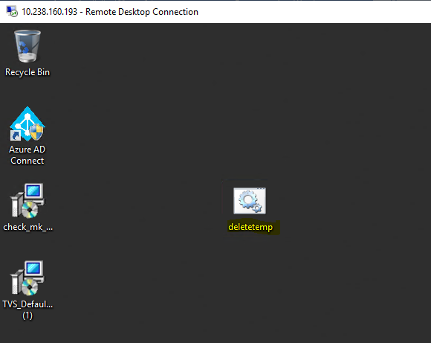

**Step 2:** Open Task Scheduler and Click on Create Task.

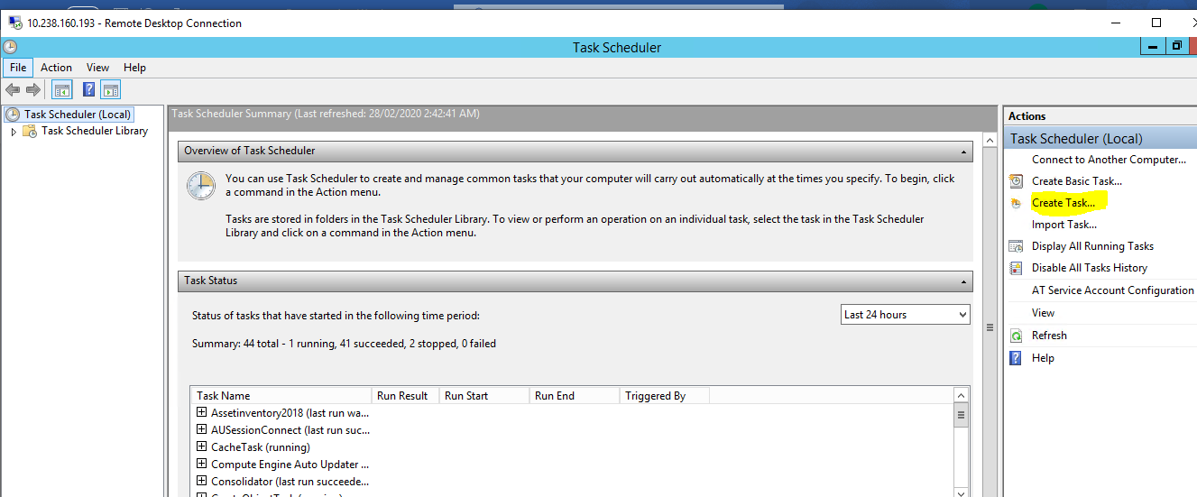

**Step 3:** Create a Name for the Task and Proceed the below steps.

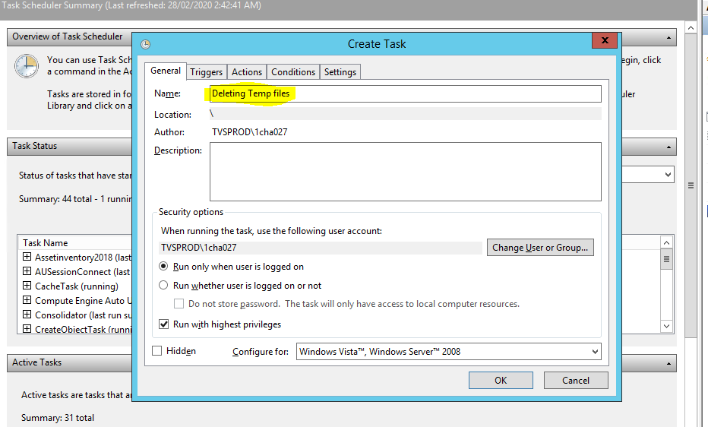

**Step 4:** Set the timings for the task to execute. Refer below screenshot.

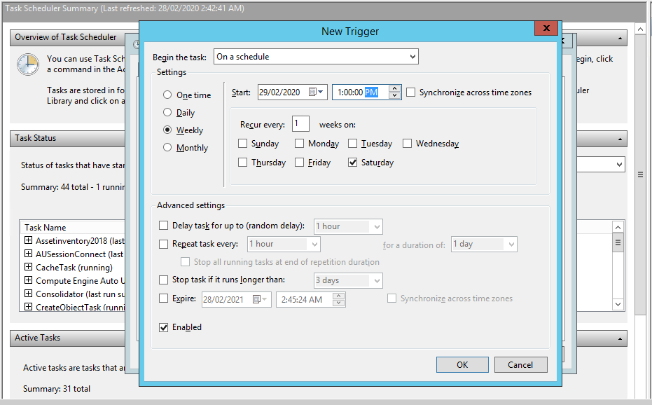

**Step 5:** Set the path by selecting the deletetemp file which we have saved in desktop and choose the path location.

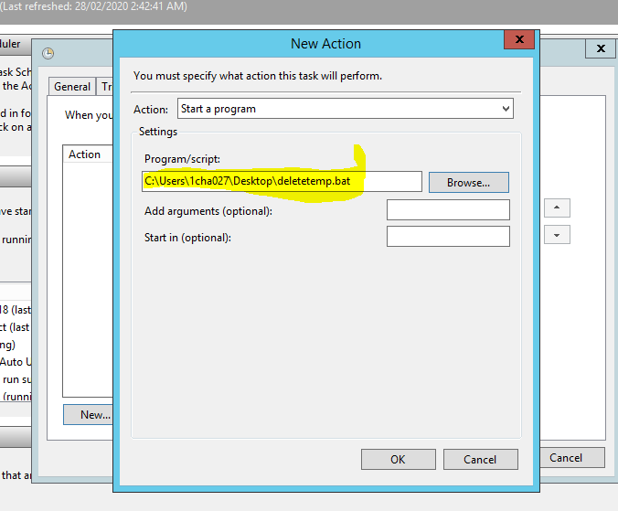

**Step 6:** In conditions dialog box uncheck the below check Box.

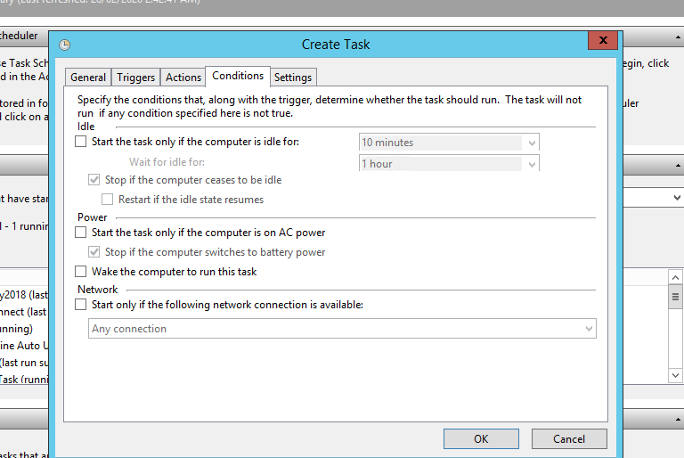

**Step 7:** In Settings dialog Box check and uncheck the below options and click ok to proceed.

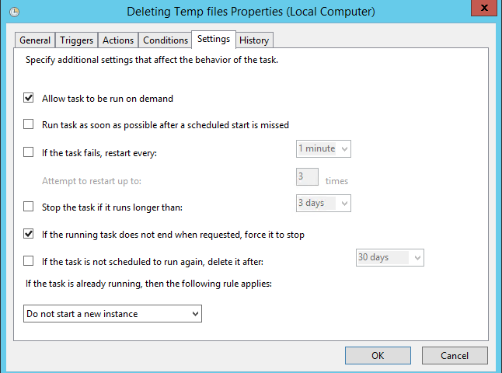

**Step 8:** After completing you can view the created Task here.

